# 

# **Jenkins 2**

Trainee Name : Aditya Upadhyay

Newers ID : 3978

Mentor Name : Tarun Saxena

College : UPES

**1. Create a jenkins pipeline Job to delete redundant docker images daily at 1 AM UTC.**

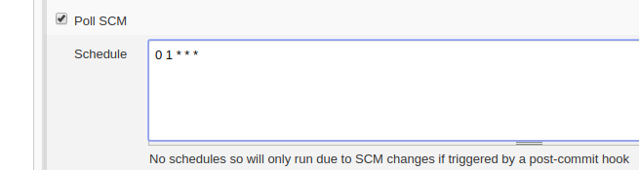

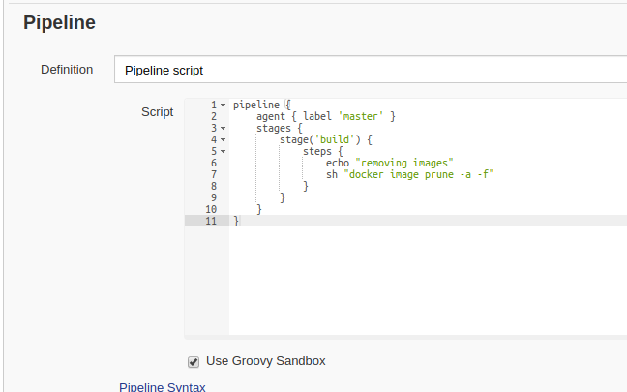

**2. Create a shared library function to convert error and success output into a colourfull output and use it in the upcoming questions(Hint: use ANSI color).**

**Step 1​ : Install AnsiColor plugin**

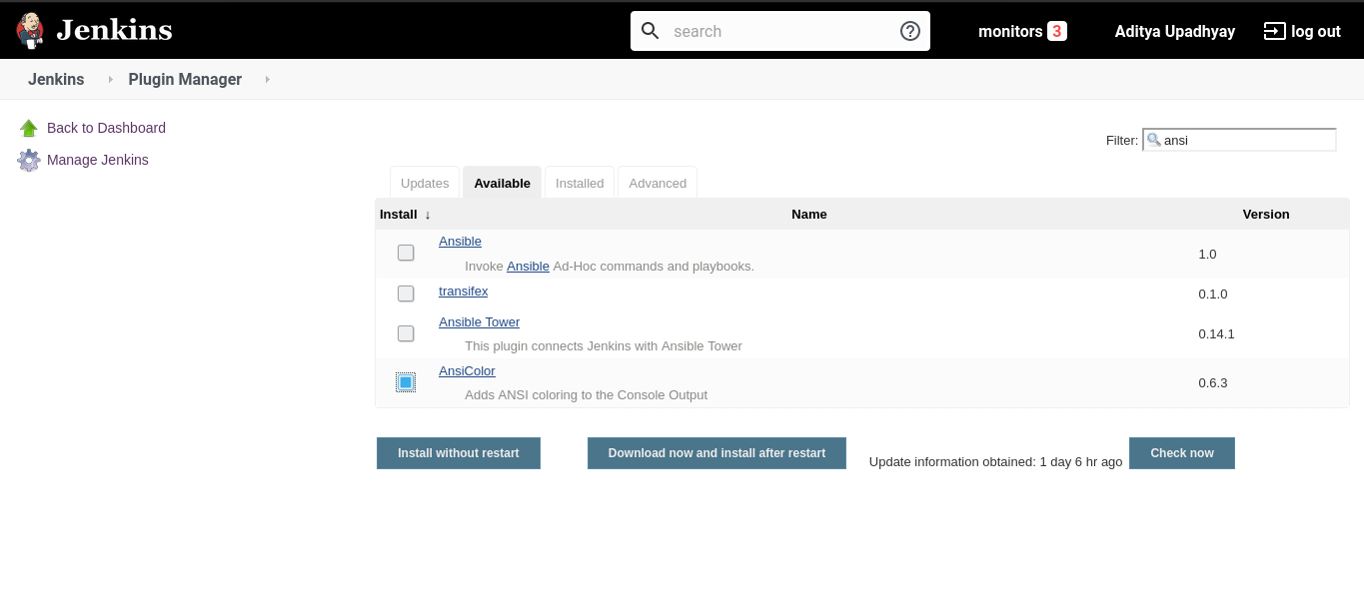

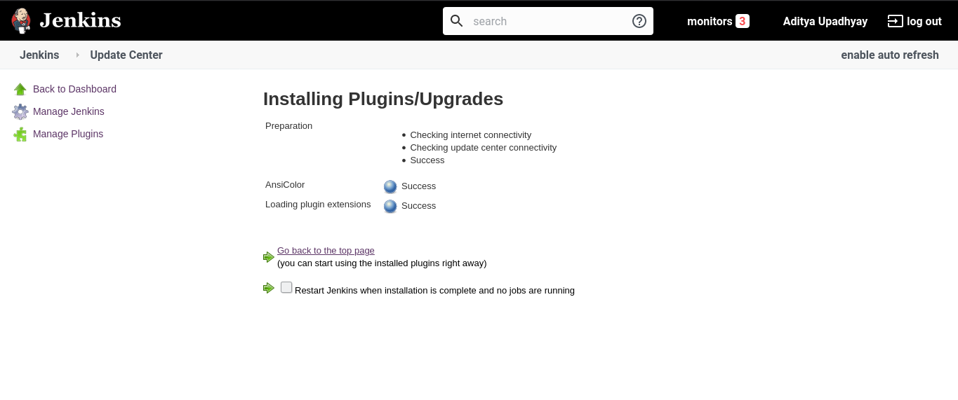

**Step 2​ :Create a git repo and add groovy script to change color.**

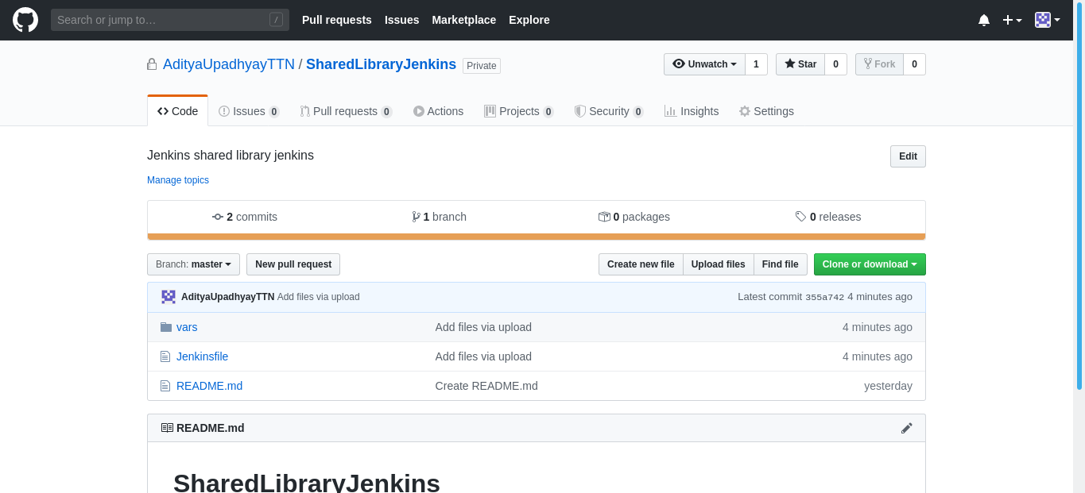

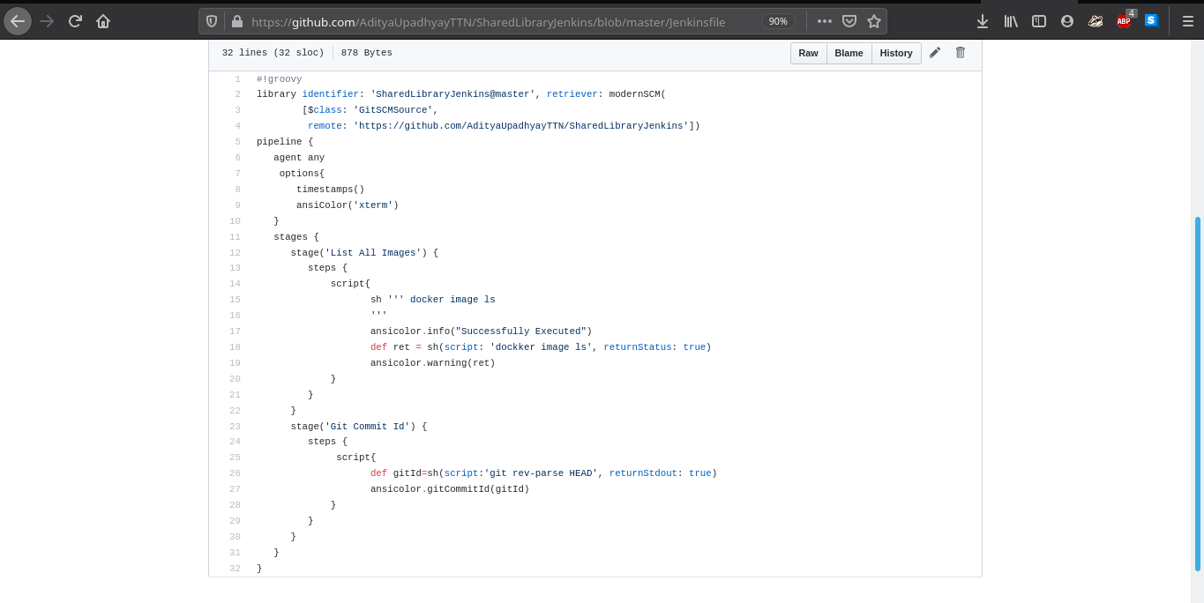

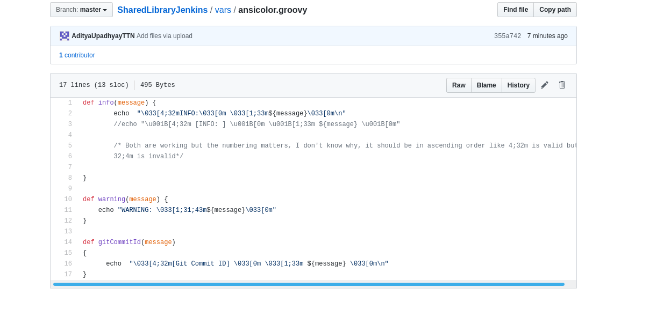

**Step 3​ :Add shared library in Manage Jenkins → Configure System → Global Pipeline**

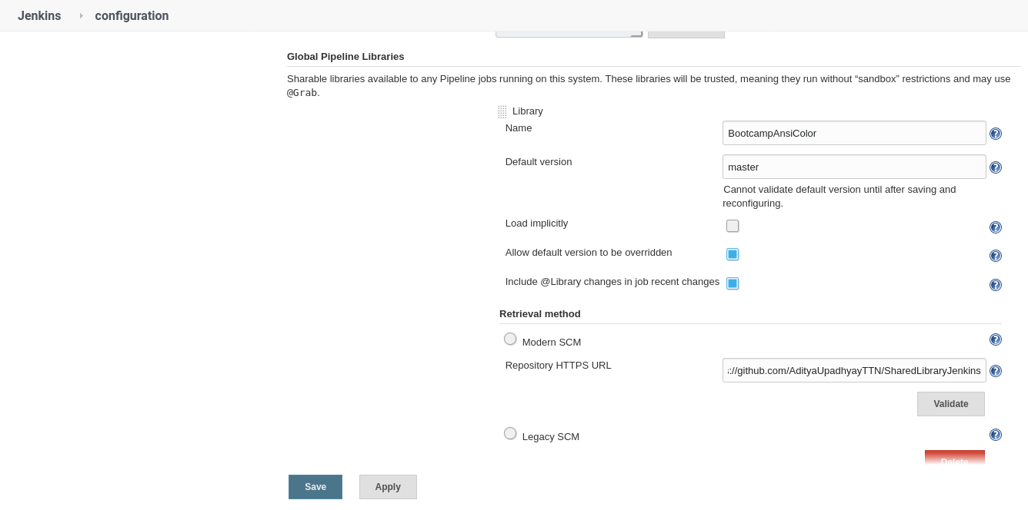

**Step 4​ : Create a pipeline job in jenkins**

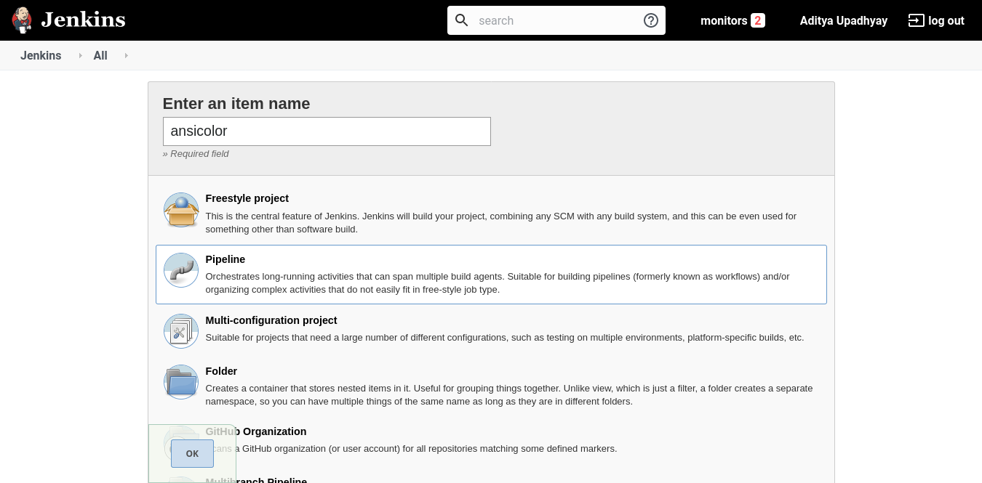

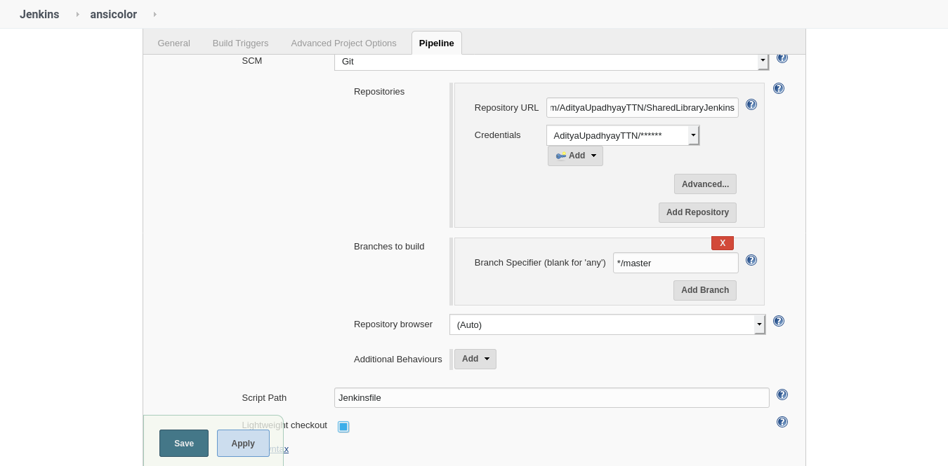

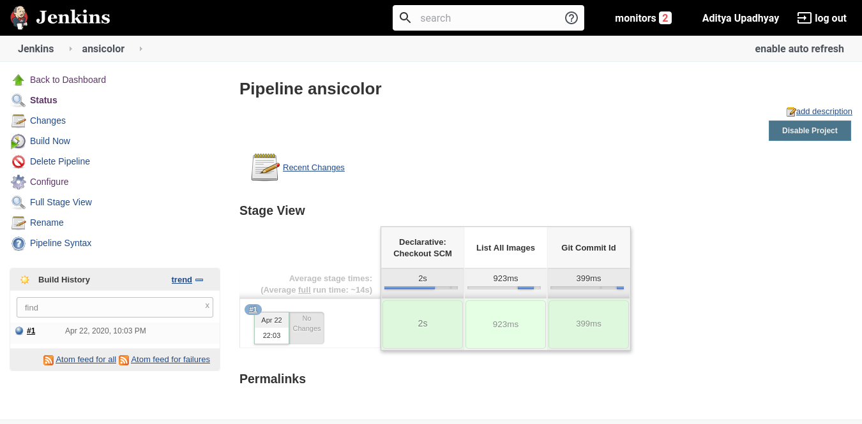

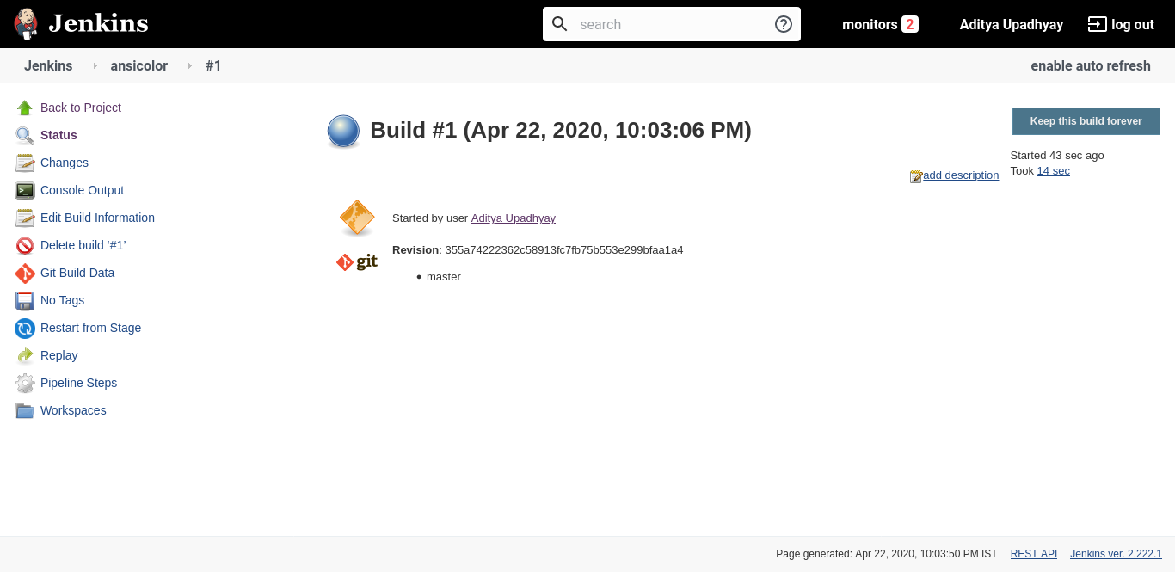

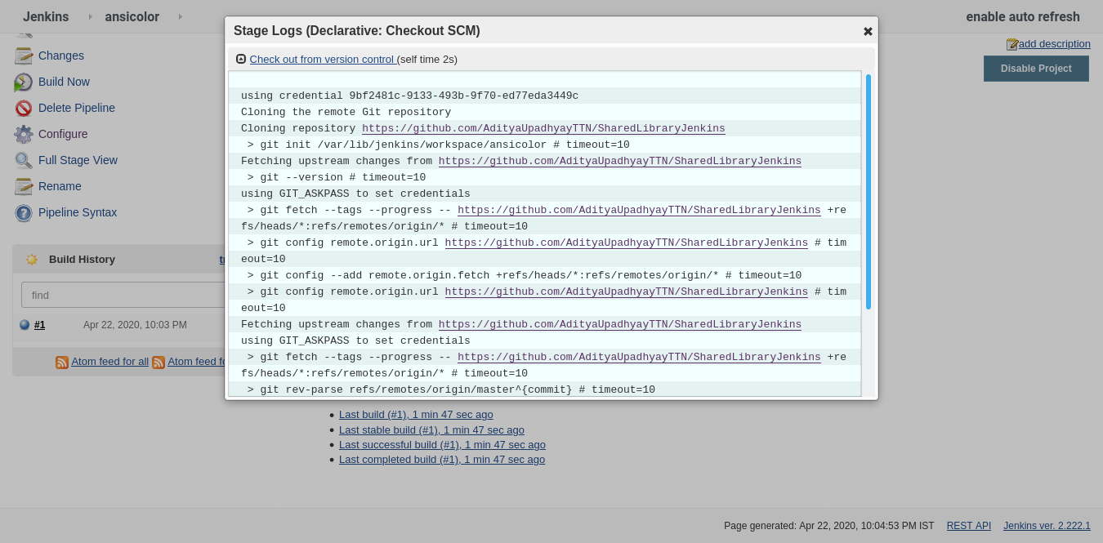

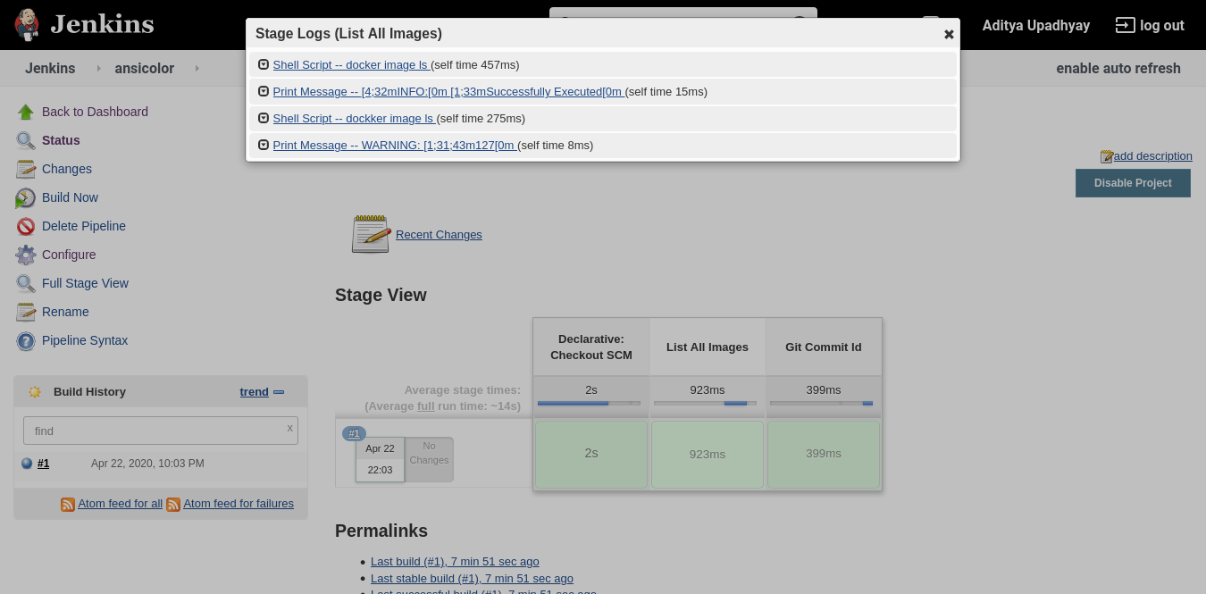

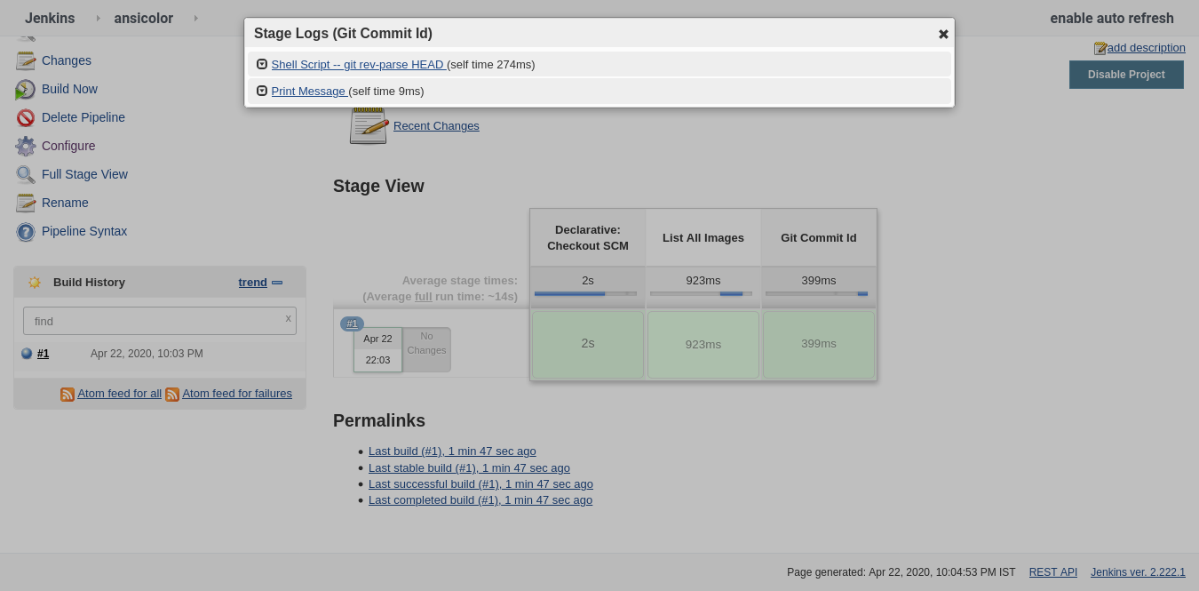

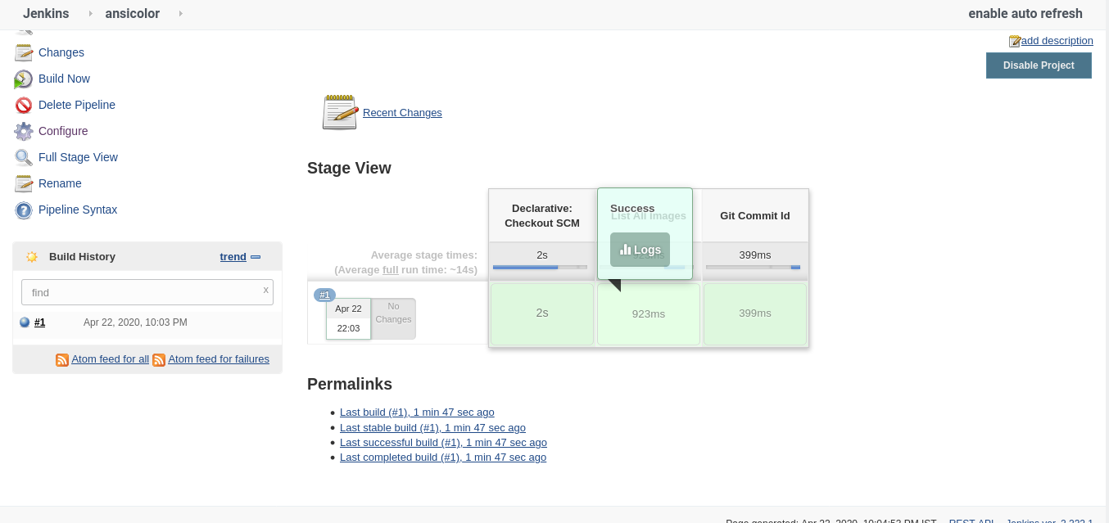

**3. Create a function in the same shared library to output git commitID.**

